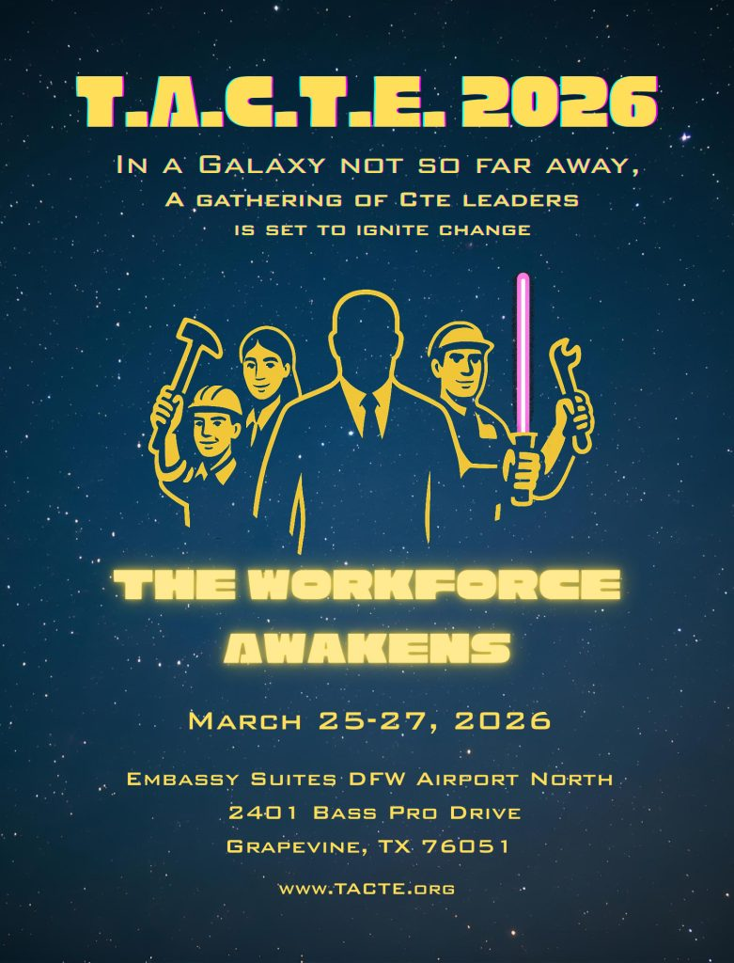
TACTE Board of Directors
Stacy Ebert, President
Kevin Morris, Vice President
Ebony Dennis, Secretary
Michelle Truberstein, Treasurer
D’Wayne Shaw, Past President
Davis Merril, Conference Co-Chair and Vendor Committee
Kristin Walker, Conference Co-Chair
Tim Park, Vendor Committee and Raffle Coordinator
Pete Avalos, Vendor Committee
Thomas Holt, Vendor Committee
Vera Lewis, Raffle Coordinator
Samantha Uriegas
William Fanning
Mary Rivard
Lesley Olson, Executive Director

Spring 2026 TACTE Conference – The Workforce Awakens
Wednesday
7:30 - 4:00 | Registration Check-In
9:00 - 11:30 | Pre-Conference: The Future of the Federal Role In CTE – Michael Brustein.
11:30 - 1:00 | Conference Luncheon Buffet in the Atrium / Networking Break
Opening General Session
1:00 – 2:00 | Welcome/Introductions / TACTE Business Meeting / Vendor Recognition
2:00 – 3:15 | Conference Keynote – Mark Perna – The Paradigm Shift Starts Here.  Unleashing Passion, Purpose, and Performance in Younger Generations
3:15 – 3:45 | Vendors’ Engagement /Networking Break
3:45 – 4:45 | Breakout Sessions
  Cross Timbers 1 & 2 | Aligning your Galatia Ships: Industry Lead Partnerships Powering Workforce Readiness
  Cross Timbers 3 | Empowering Educators: Breaking Barriers in Non-Traditional Career Pathways and Breaking Barriers: Family Engagement for Non-traditional Careers
  Heritage 4 | Perkins Update: Implementation of the New Grant Management System for the FY 2027 Grant Cycle & Perkins V Data Dashboard Updates
  Heritage 5 | “Mastering the Mega Trends Shaping the Next Generation of Talent”
  Heritage 6 & 8 | WECM 101 Workshop
4:45 – 5:15 | TACTE New Member Orientation
6:00 – 7:30 | TACTE President’s Dinner
Thursday
8:30 - 9:30
  Cross Timbers 1 & 2 | Perkins 101
  Cross Timbers 3 | Preparing for Perkins: Site Visit Insights and Leadership Grant Objectives and Strengthening the Pipeline: Secondary CTE and Postsecondary Technical Partnerships
  Heritage 4 | Engaging Community Organizations and Businesses to Enhance Student Training through Real-World Projects and Awakening the Workforce: An Interactive 8th Grade Career Fair Model
  Heritage 5 | Closing the Hidden Gaps in Allied Health Pathways: From Admission to the First Semester
  Heritage 6 & 8 | HB8 Updates
9:30 - 10:00 | Vendors’ Engagement /Networking Break
10:00 - 11:00
  Cross Timbers 1 & 2 | Padawan to Professional: Launching Career-Ready Cyber Professionals with Experiential Capstone Engagements
  Cross Timbers 3 | AI-Assisted Curriculum Alignment as Workforce Infrastructure: Reducing Friction for Partnerships, Apprenticeships, and Credentials
  Heritage 4 | Funding your Alliance: Workforce Grants to Upskill Your Rebels
  Heritage 5 | Creating High Wage, High Demand (HWHD) Pathways Through Strategic CTE Program Redesign
  Heritage 6 & 8 | Aligning CTE Grant Funding - SB 1786
11:00 - 12:30 | Conference Luncheon Buffet in the Atrium/Networking and Vendor Break
12:30 – 1:45 | Conference Keynote – Lisa Ryan – Build and Retain an Engaged Workforce.
1:45 - 2:15 | Program of Excellence & Lindle Grigsby Leadership Award
2:30 – 3:30
  Cross Timbers 1 & 2 | The Pathway Awakens: Dual Credit Welding and Industry Alliance and Education Pathways and Eliminating Barriers for Child Development Students
  Cross Timbers 3 | TACTE Program of Excellence
  Heritage 4 | Business Pathways and Innovations for CTE Programs and Future of Work in the Rio Grande Valley and Texas
  Heritage 5 | The Healing Force Awakens: Stackable, Bilingual Pathways to Non-Clinical Healthcare Careers
  Heritage 6 & 8 | Texas Opportunity High School Diploma: 2026 Update
3:30 – 4:00 | Vendors’ Engagement/Networking Break
4:00 – 5:00
  Cross Timbers 1 & 2 | WECM 101 Workshop
  Cross Timbers 3 | Rogue Welders: Advancing Robotic Welding Education with NSF ATE”
  Heritage 4 | Using the Force of Perkins: Rebuilding a Criminal Justice Institute from Compliance to 100 Percent Outcomes
  Heritage 5 | Help Me JET Grant! You're My Only Hope.
  Heritage 6 & 8 | The AI Strikes Back: Preparing Students for Jobs in a Galaxy Not Yet Created
Friday,
9:00 – 11:00 | Friday Closing Keynote – Bryan Ashton, Trellis  Evolving for the Modern Learner: Updates on Education Policy in Texas and Washington
11:00 | Conference Adjourned

